GUARDIAN EXCLUSIVE
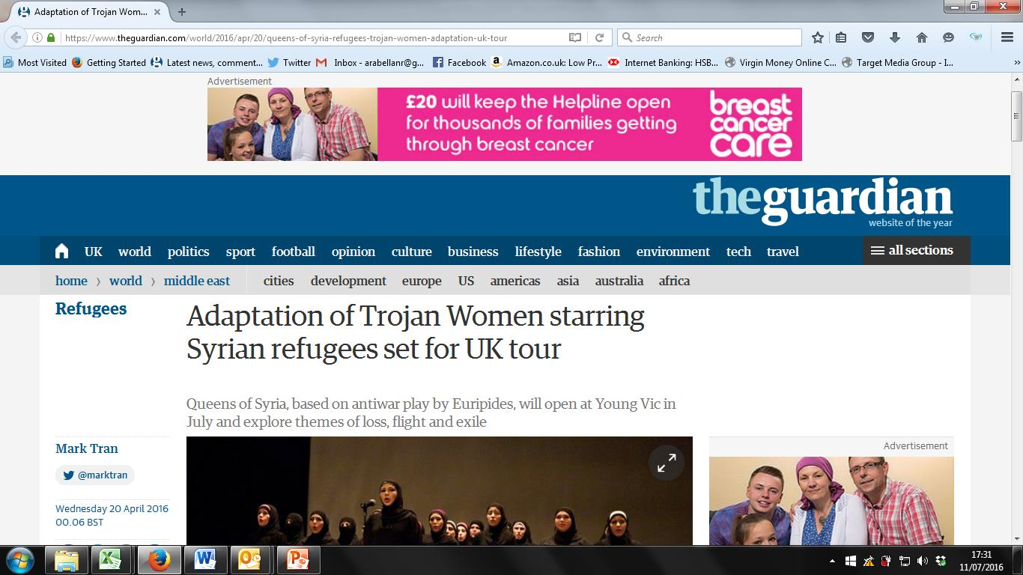
Queens of Syria – PR Report

EVENING STANDARD – LONDONER’S DIARY 22.04.16
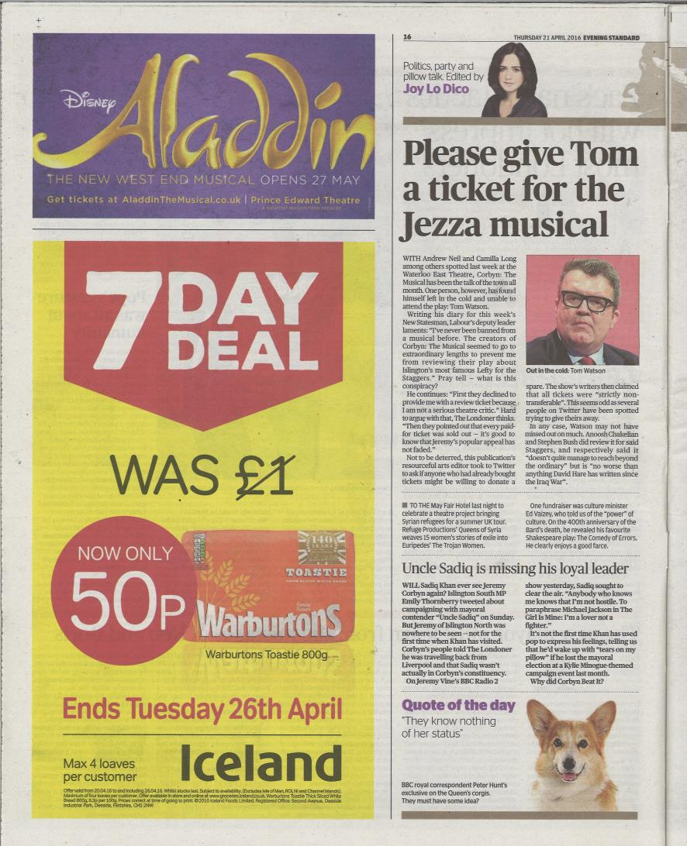

LONDON WEEKLY NEWS 26.04.16
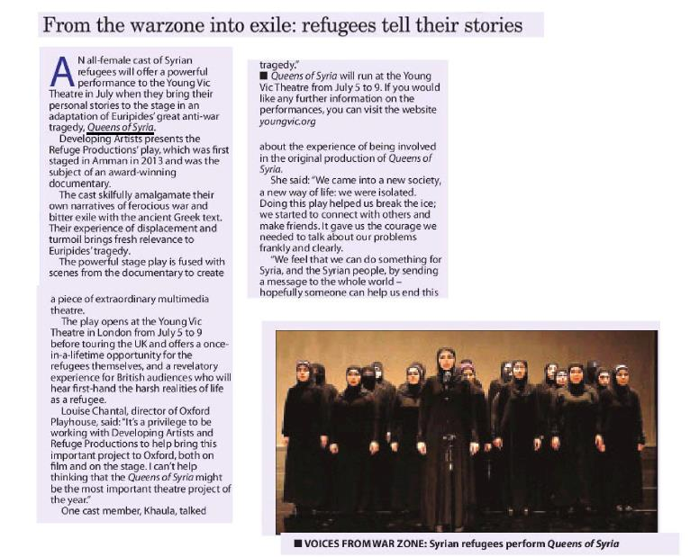
Queens of Syria – PR Report

YORKSHIRE EVENING POST 21.06.16
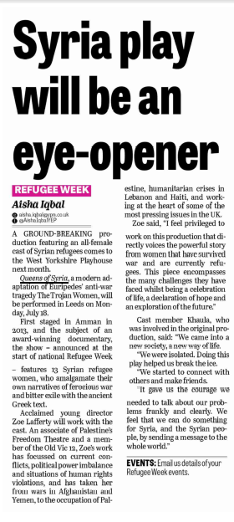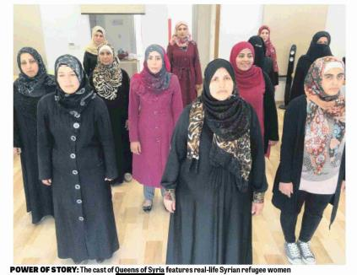
Queens of Syria – PR Report

LIVERPOOL ECHO 22.06.16
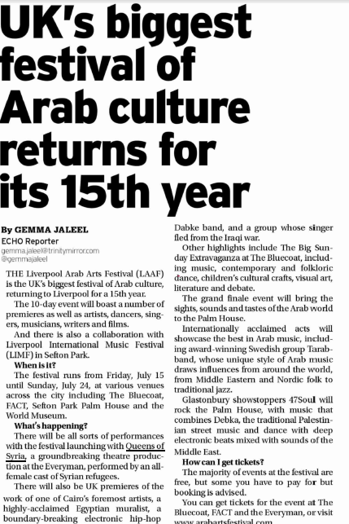
Queens of Syria – PR Report

OXFORD MAIL 23.06.16
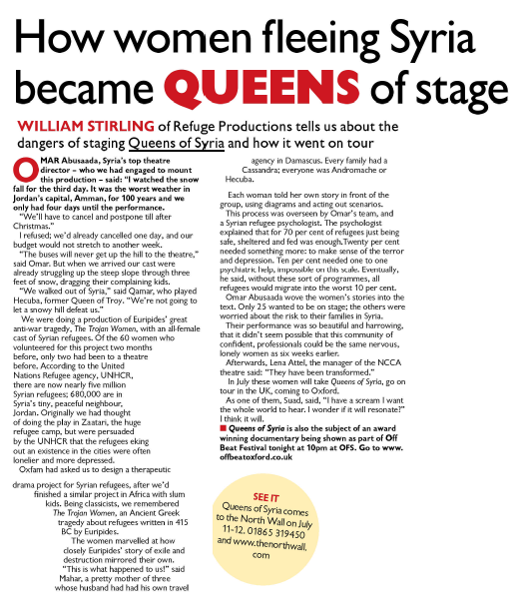
Queens of Syria – PR Report

OXFORD TIMES 23.06.16
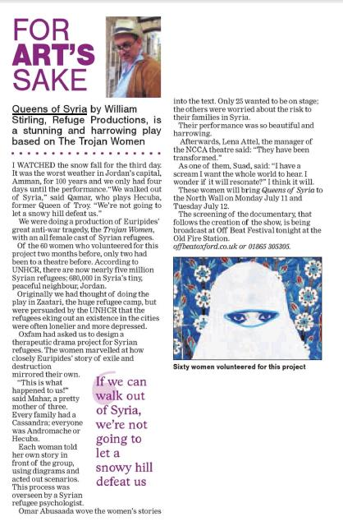
Queens of Syria – PR Report

THE OBSERVER 26.06.16
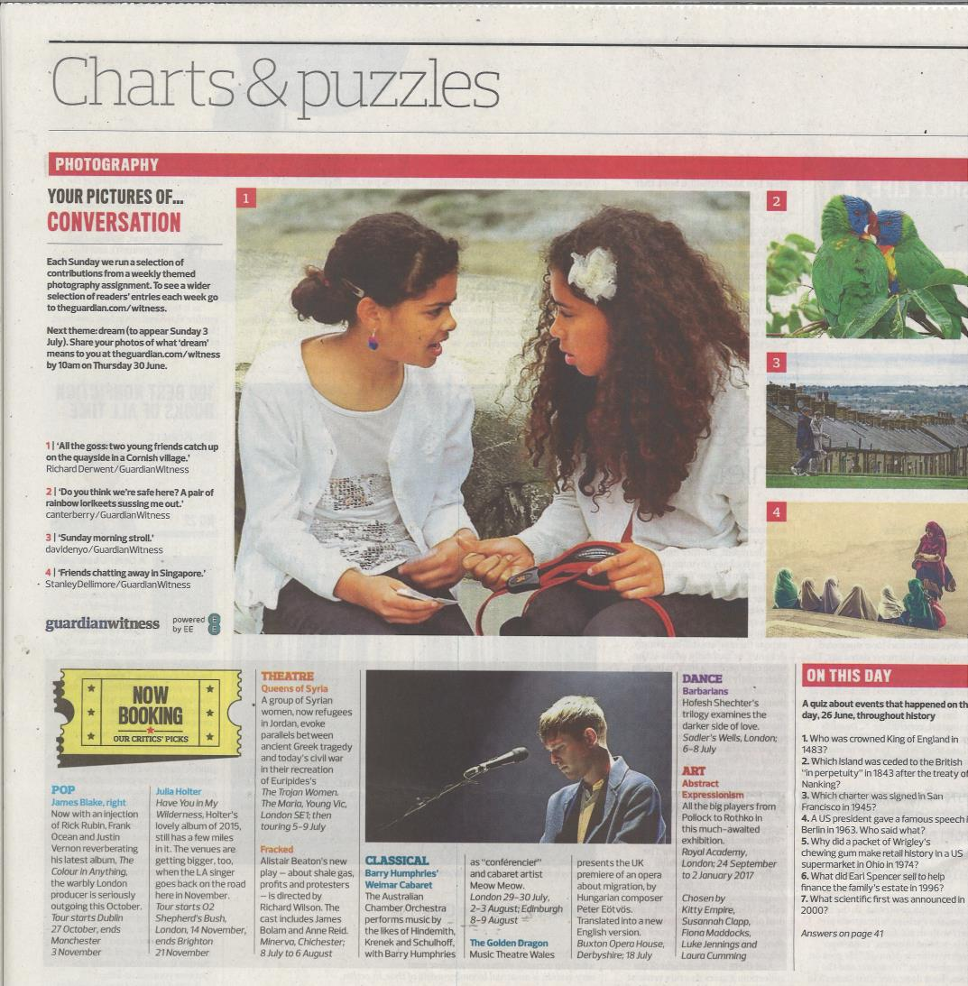
Queens of Syria – PR Report

THE STAGE 30.06.16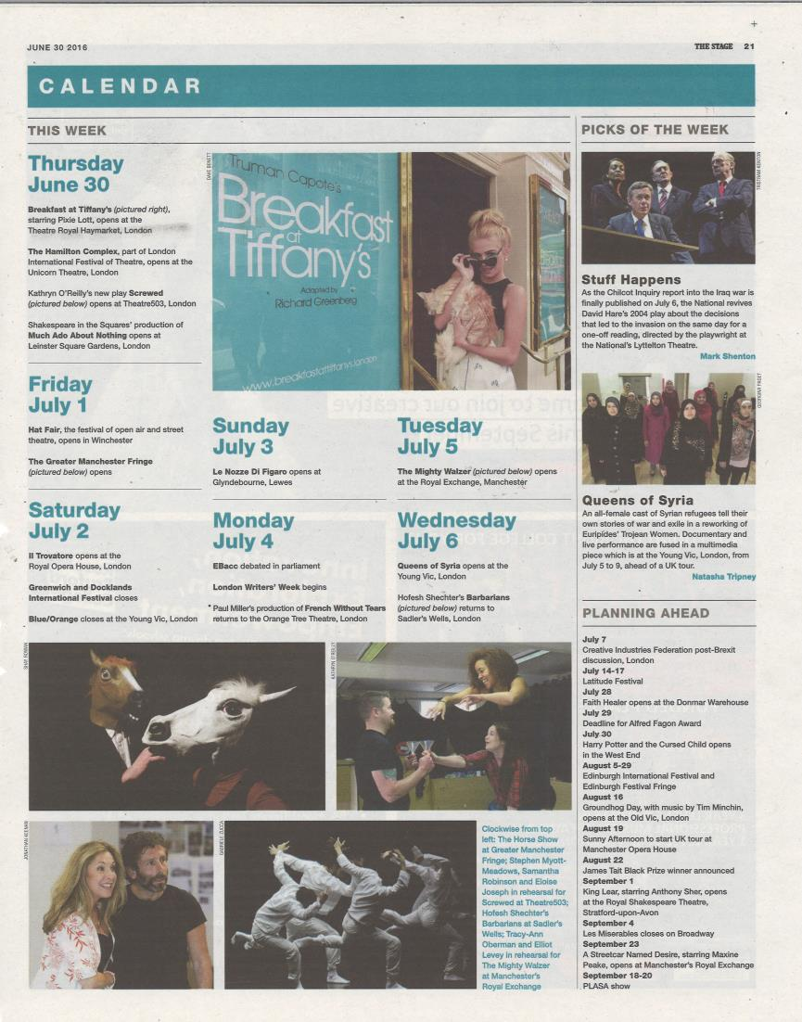
Queens of Syria – PR Report

PROSPECT MAGAZINE 01.07.16
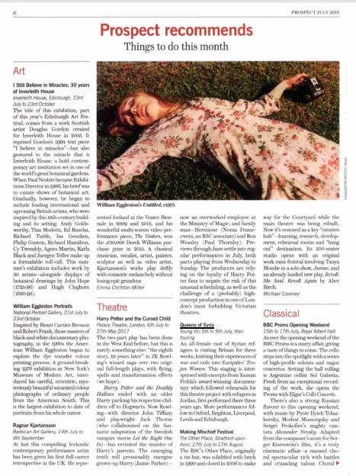
Queens of Syria – PR Report

OXFORD LIMITED EDITION 01.07.16
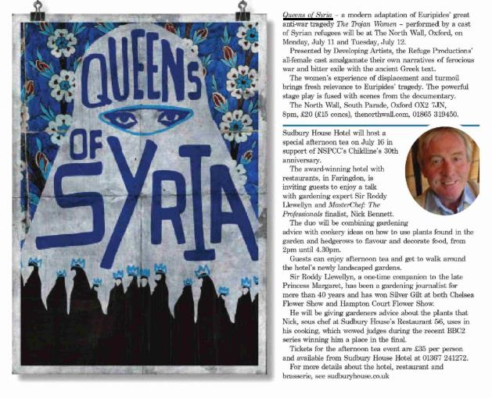
Queens of Syria – PR Report

ABSOLUTELY NORTH BY NORTHWEST 01.07.16
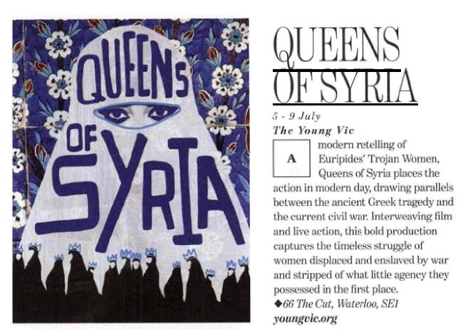
Queens of Syria – PR Report

OX MAGAZINE 01.07.16
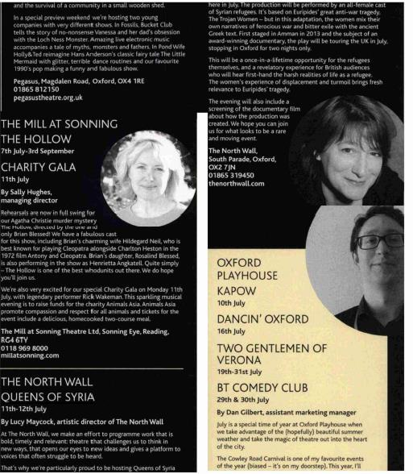
Queens of Syria – PR Report

EVENING STANDARD – GO GUIDE 01.07.16
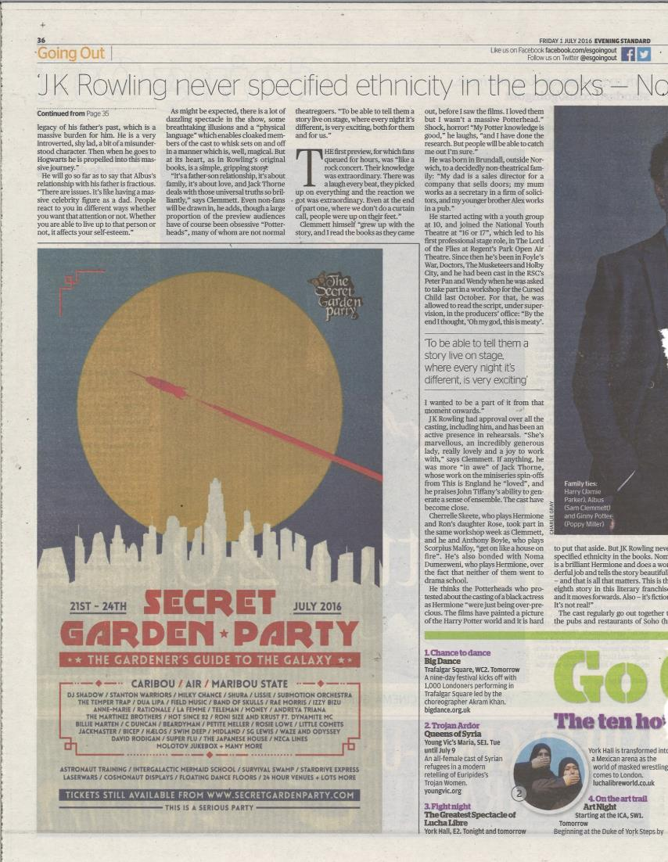
Queens of Syria – PR Report

THE SCOTSMAN 02.07.16
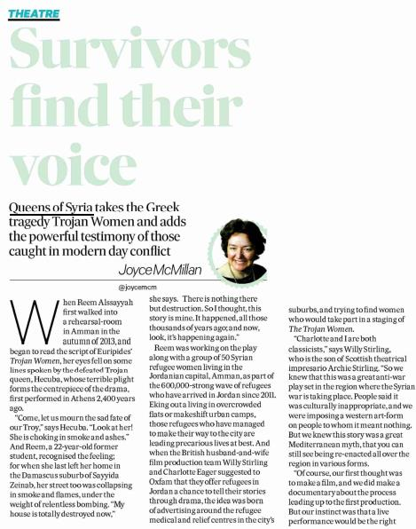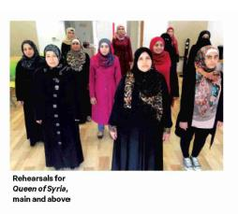
Queens of Syria – PR Report

THE SCOTSMAN 02.07.16 (CONT’D)
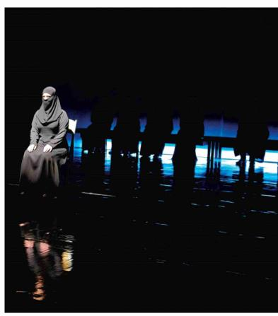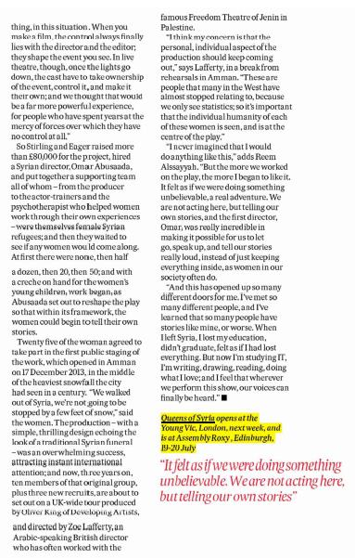
Queens of Syria – PR Report

FINANCIAL TIMES 02.07.16
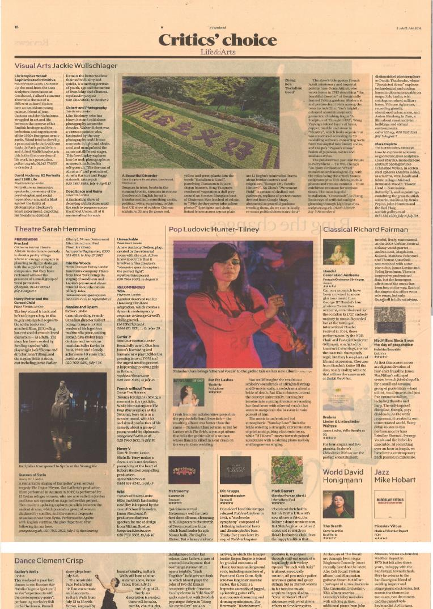
Queens of Syria – PR Report

TIME OUT 05.07.16
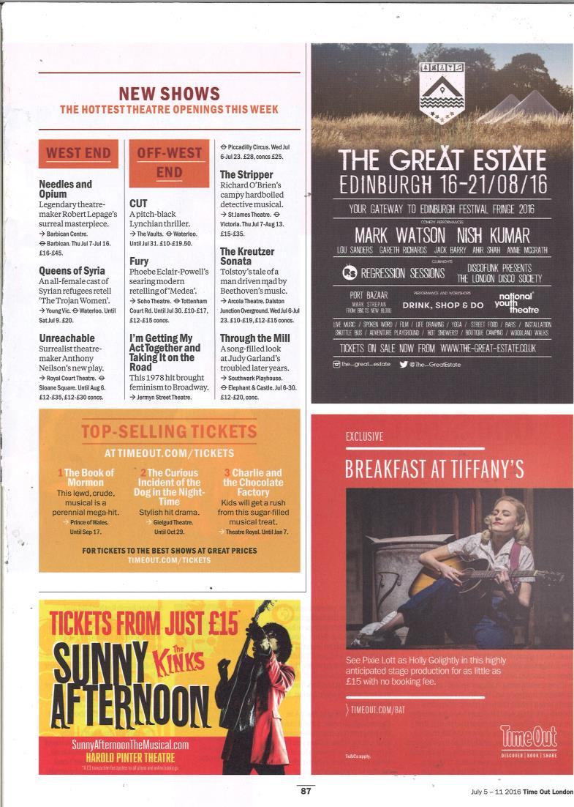
Queens of Syria – PR Report

PRESS CONFERENCE – 05.07.16

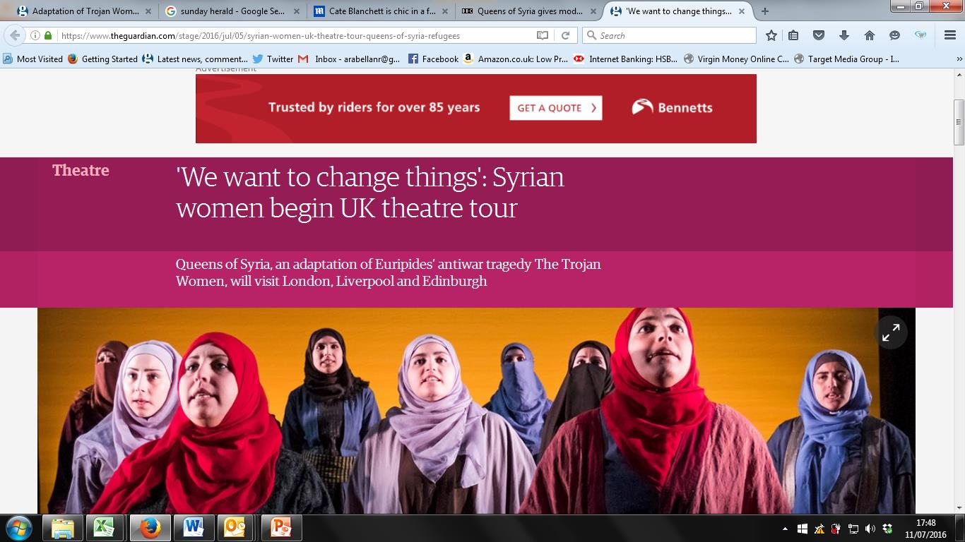

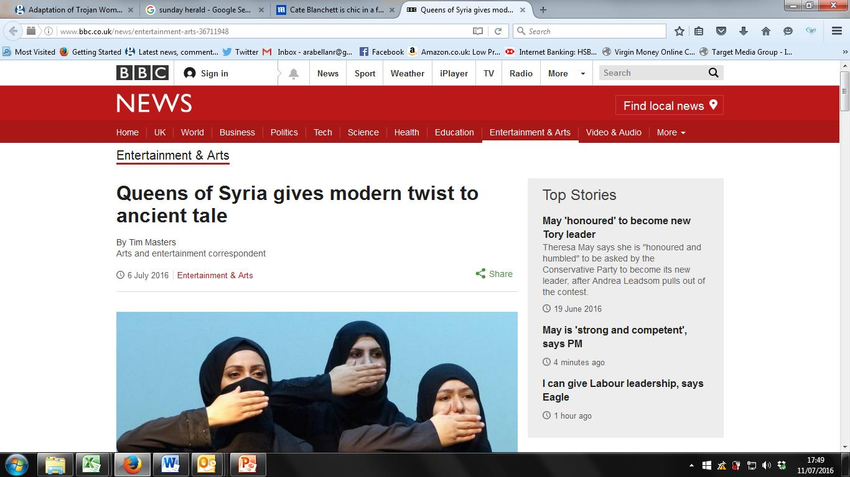

CATE BLANCHETT PRESS NIGHT VISIT – MAILONLINE 06.07.16
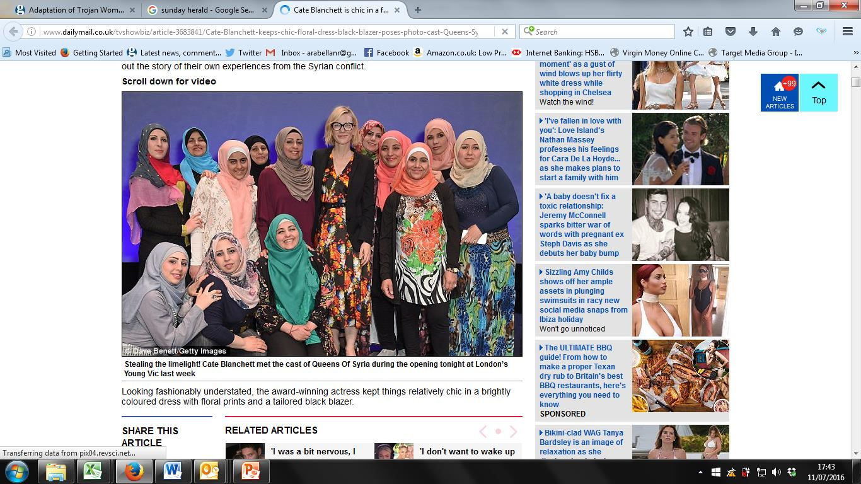

EVENING STANDARD 07.07.16
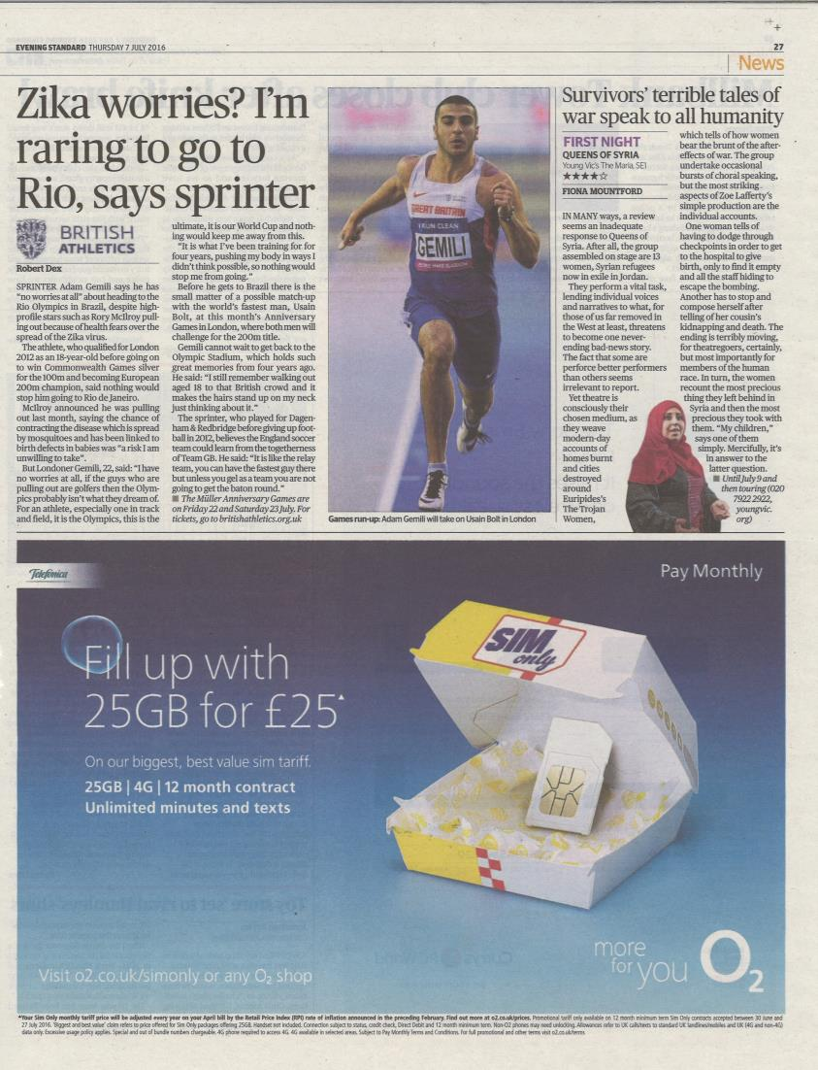
Queens of Syria – PR Report

THE TIMES 08.07.16
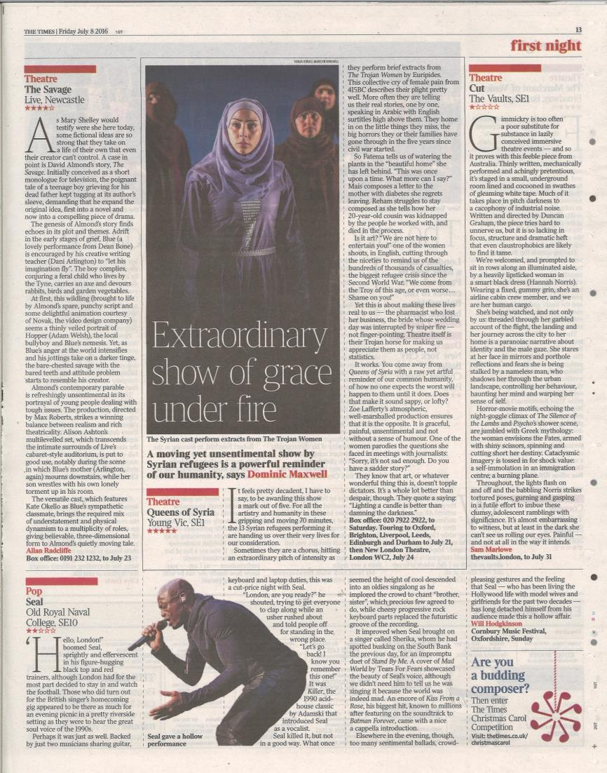Queens of Syria – PR Report

THE GUARDIAN 08.07.16
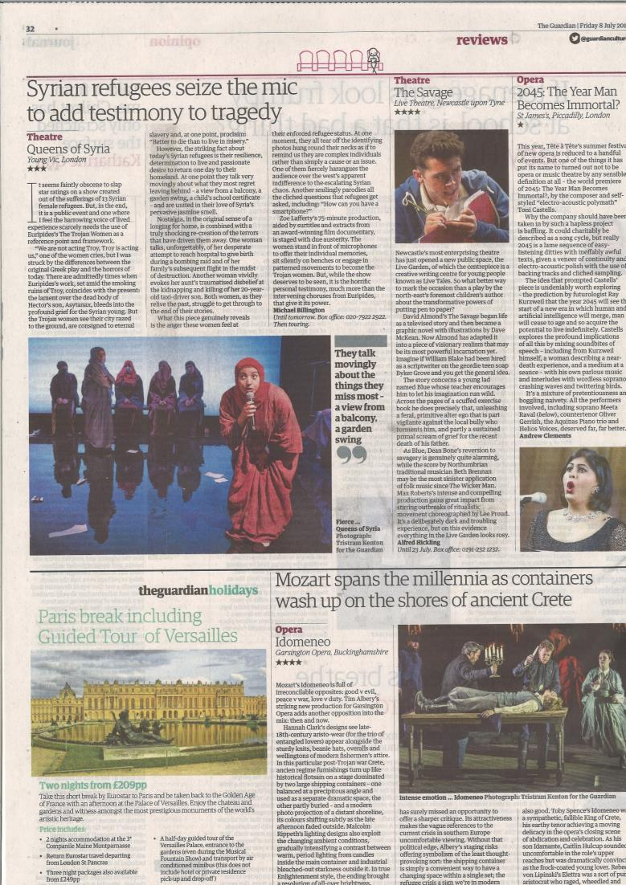
Queens of Syria – PR Report

DAILY MAIL 08.07.16
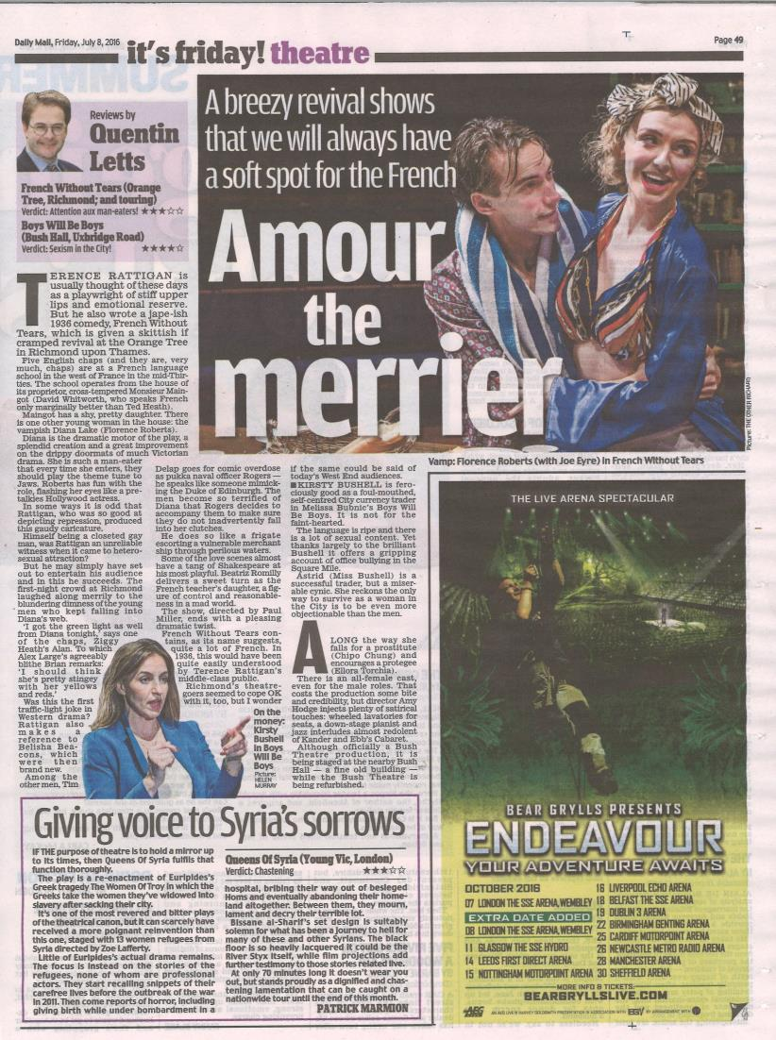
Queens of Syria – PR Report

BRIGHTON ARGUS 08.07.16
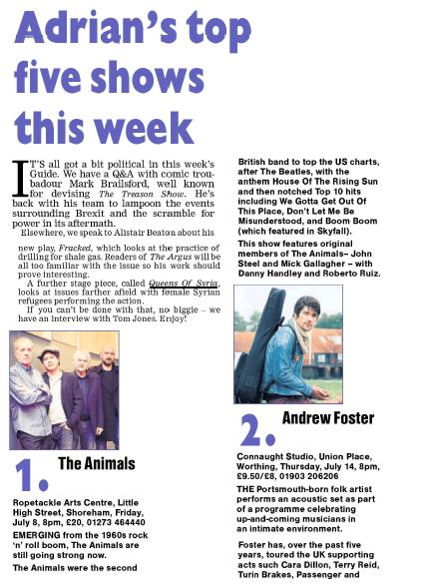
Queens of Syria – PR Report

BRIGHTON ARGUS 08.07.16
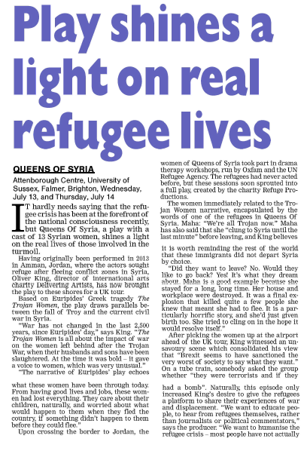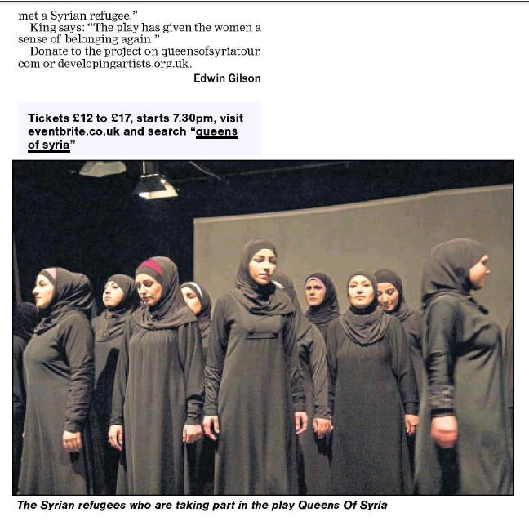
Queens of Syria – PR Report

BRIGHTON AND HOVE INDEPENDENT 08.07.16
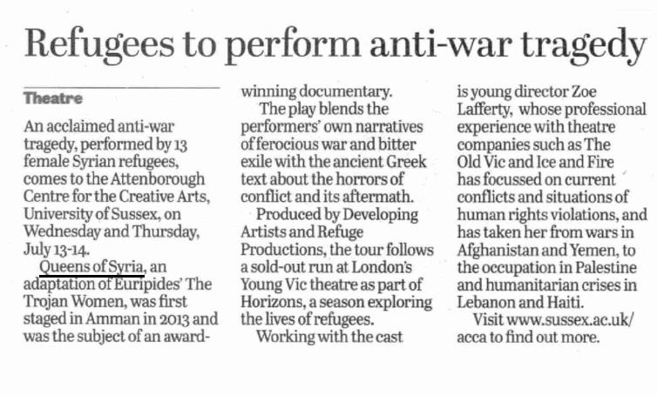
Queens of Syria – PR Report

FINANCIAL TIMES 09.07.16
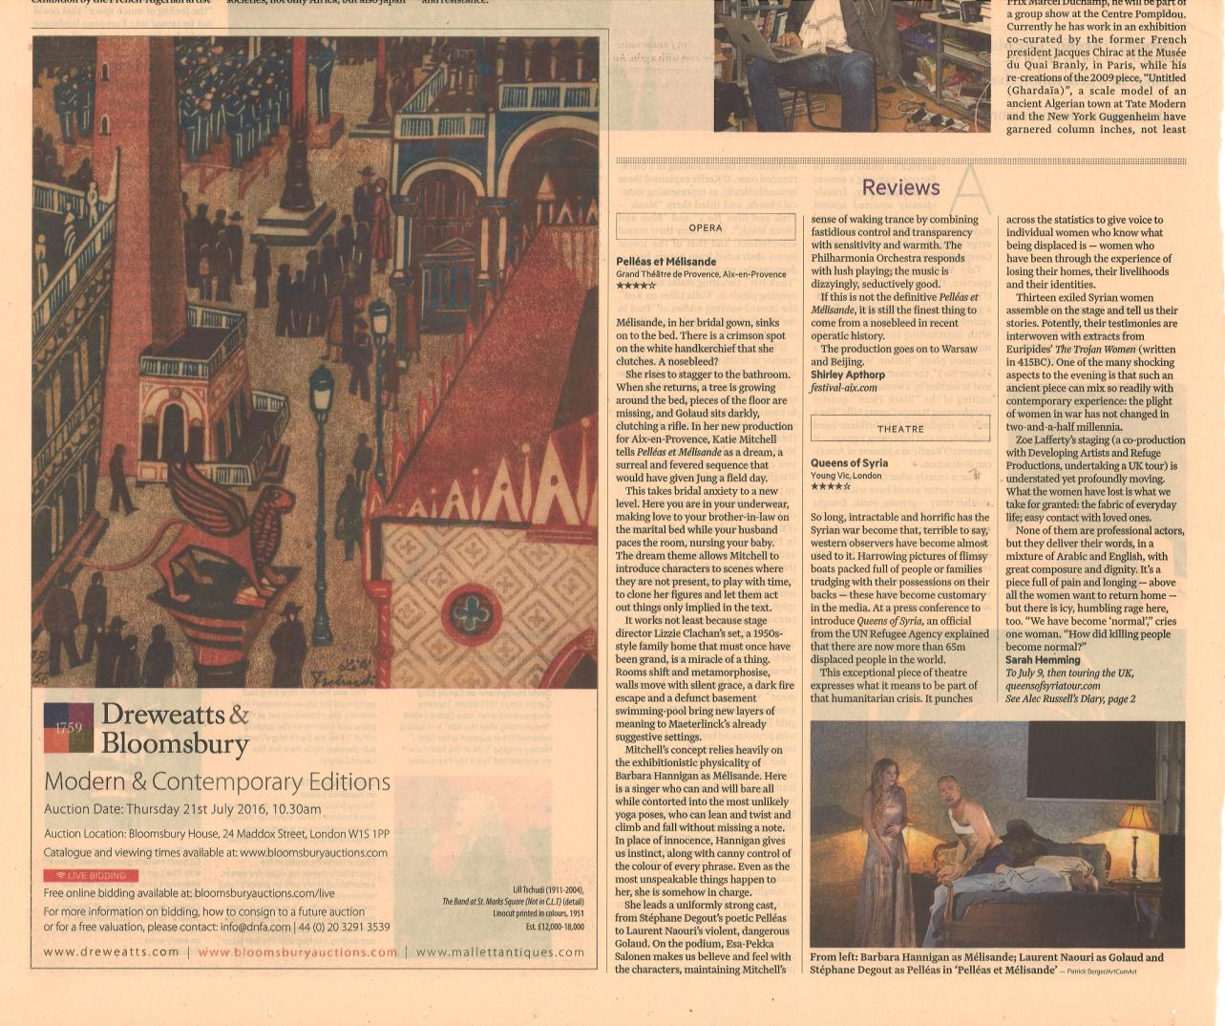
Queens of Syria – PR Report

FINANCIAL TIMES 09.07.16
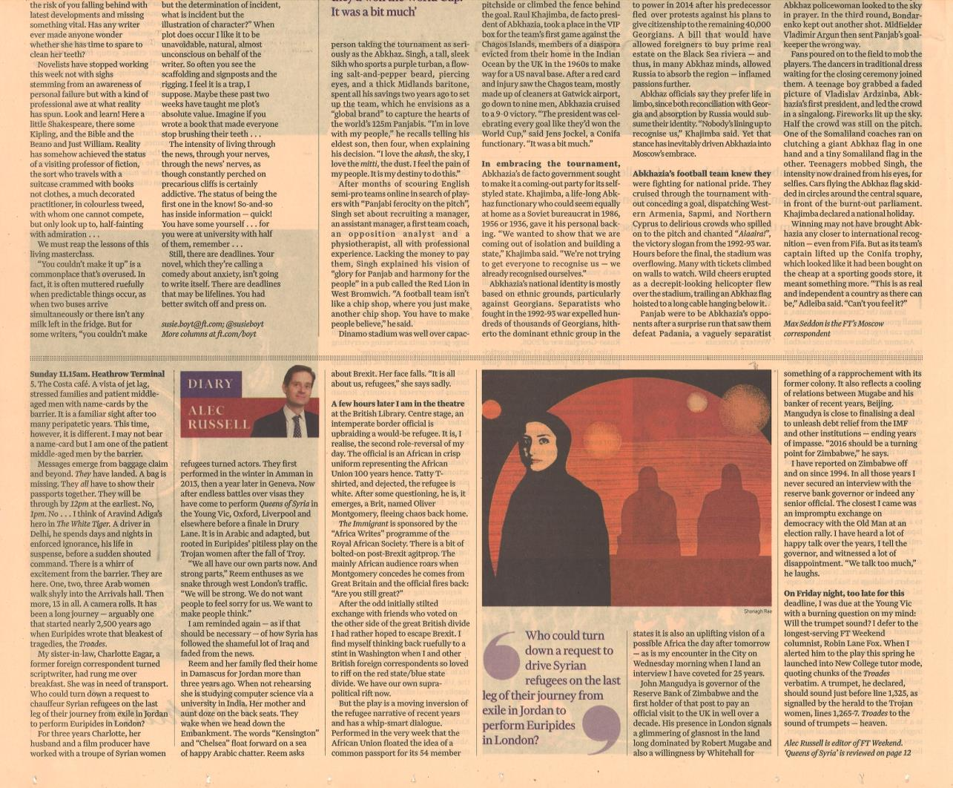
Queens of Syria – PR Report

SUNDAY TIMES CULTURE 10.07.16
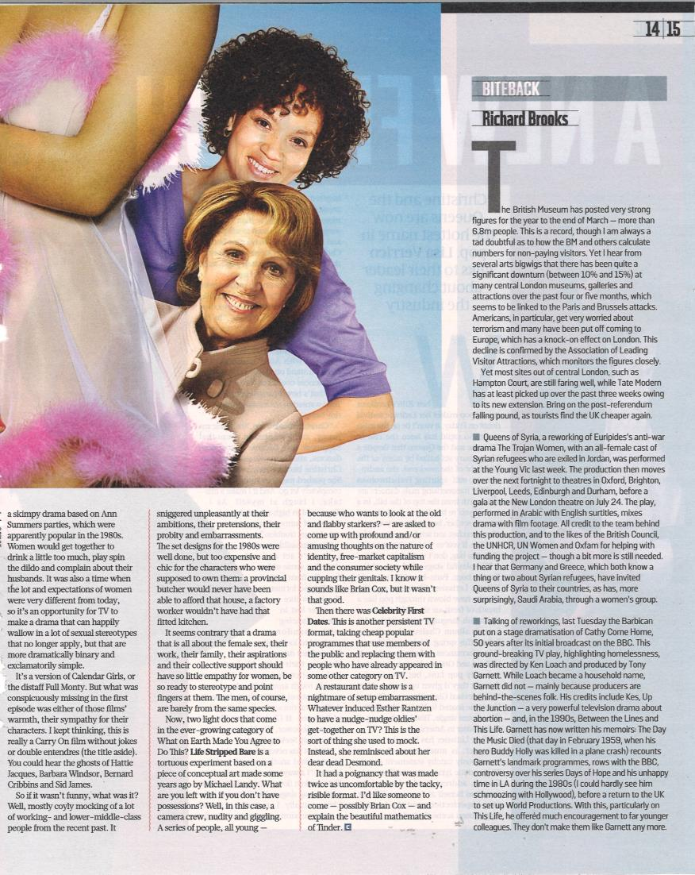
Queens of Syria – PR Report

THE OBSERVER 10.07.16
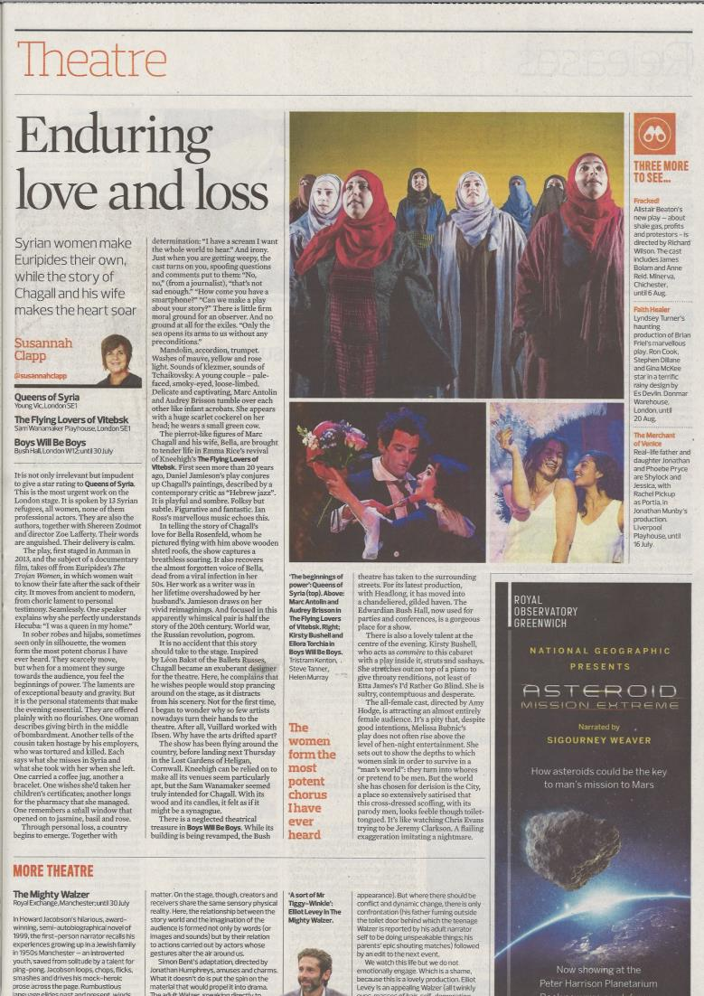
Queens of Syria – PR Report

THE I 11.07.16
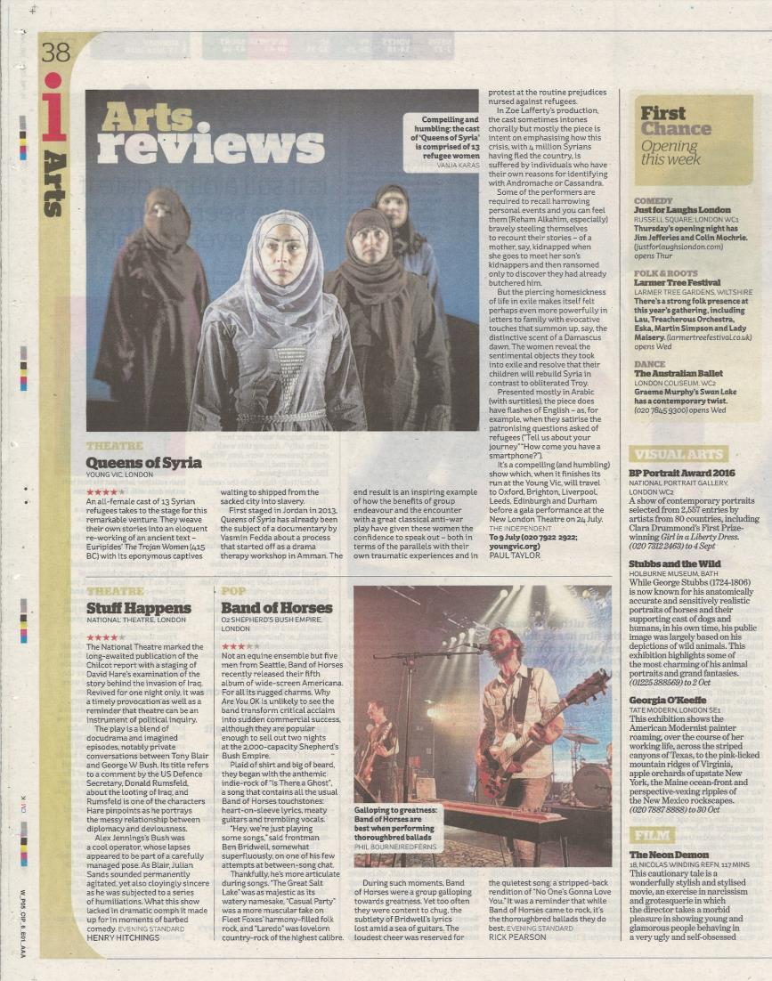
Queens of Syria – PR Report

ISLINGTON GAZETTE 14.07.16
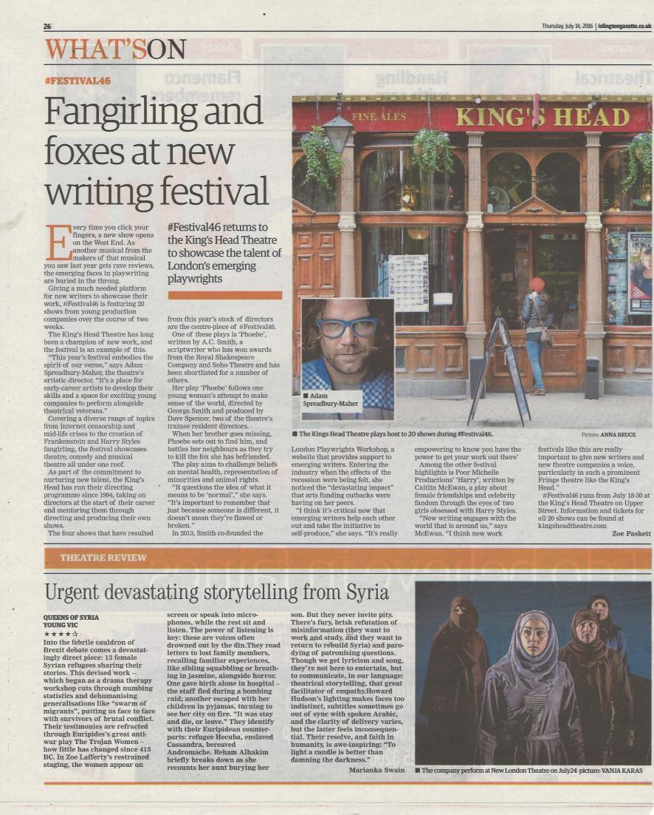
Queens of Syria – PR Report

THE STAGE 14.07.16
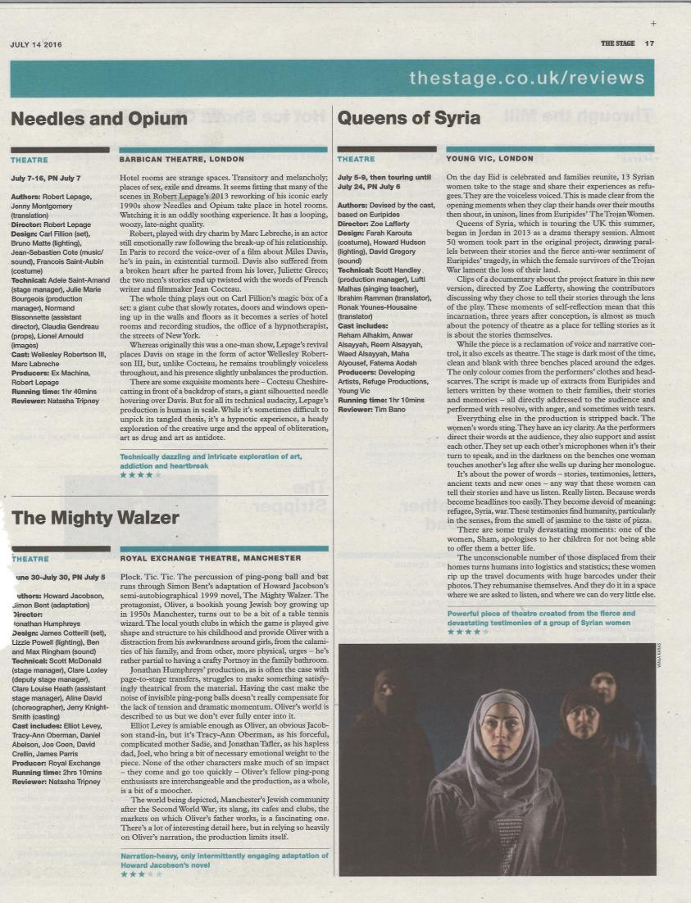
Queens of Syria – PR Report
YORKSHIRE POST 14.07.16
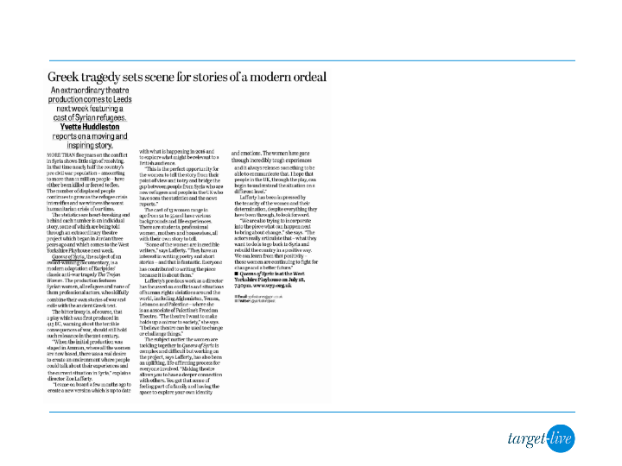
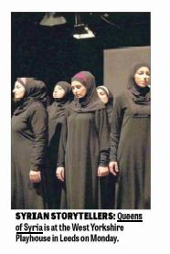
YORKSHIRE EVENING POST 14.07.16
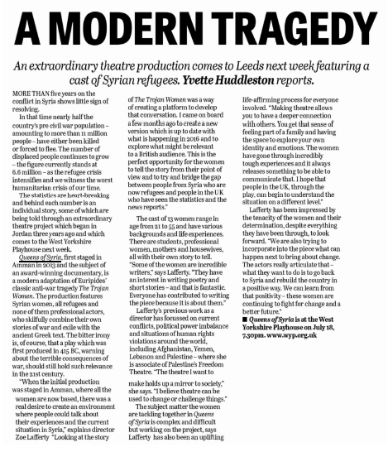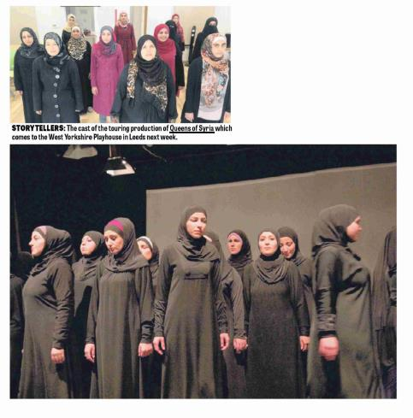
Queens of Syria – PR Report

LIVERPOOL ECHO 14.07.16
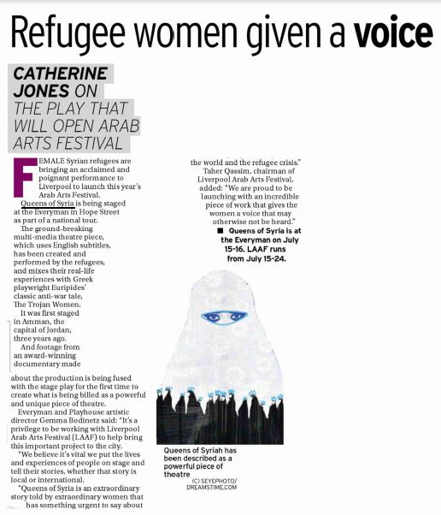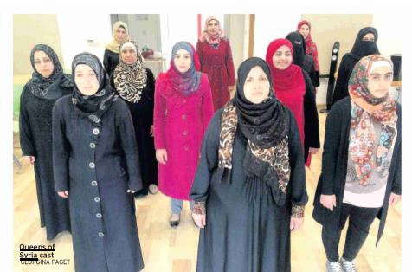
Queens of Syria – PR Report

HACKNEY GAZETTE 14.07.16
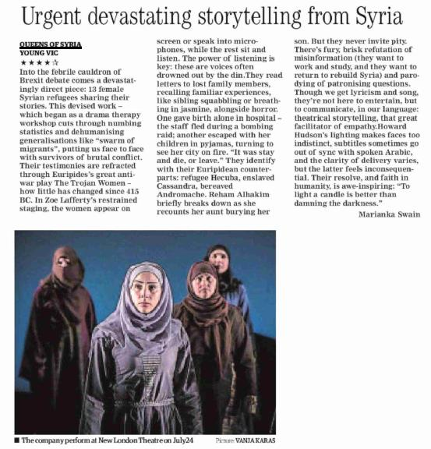
Queens of Syria – PR Report
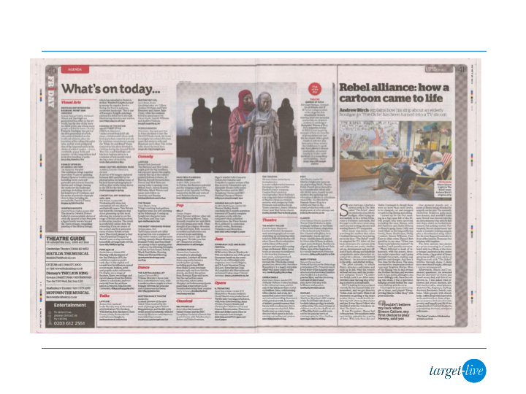
THE I 15.07.16
Queens of Syria – PR Report
SOUTH LONDON PRESS 15.07.16
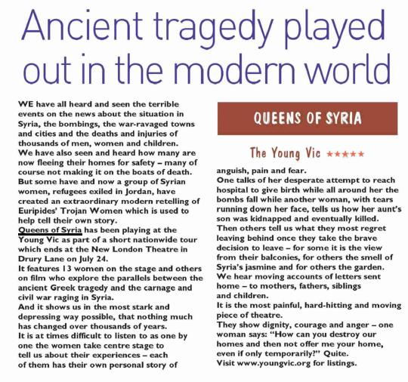
Queens of Syria – PR Report

LIVERPOOL ECHO 15.07.16
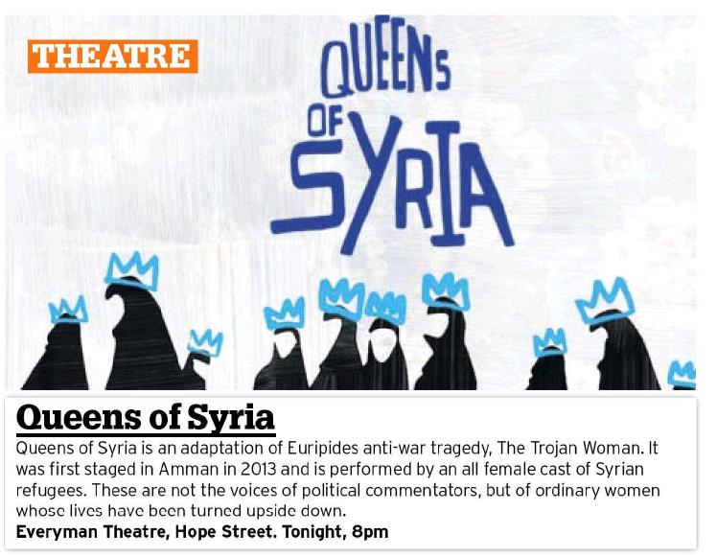
Queens of Syria – PR Report

BRIGHTON ARGUS 16.07.16
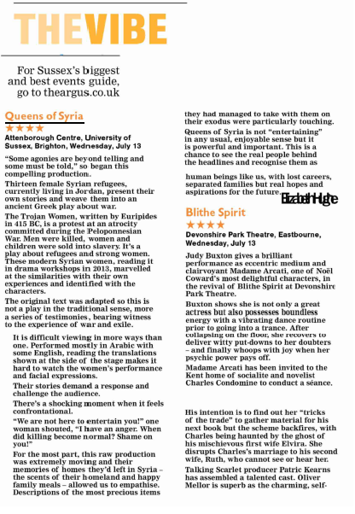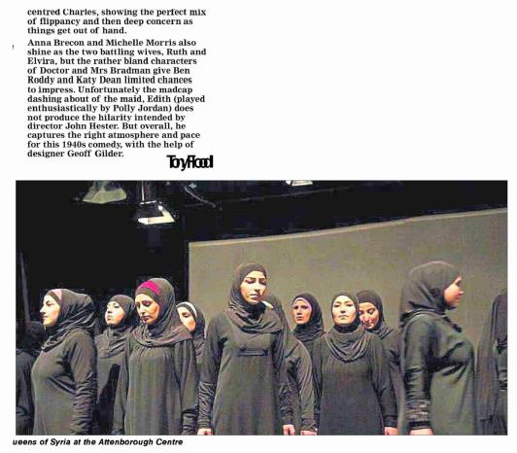
Queens of Syria – PR Report

THE TIMES 16.07.16
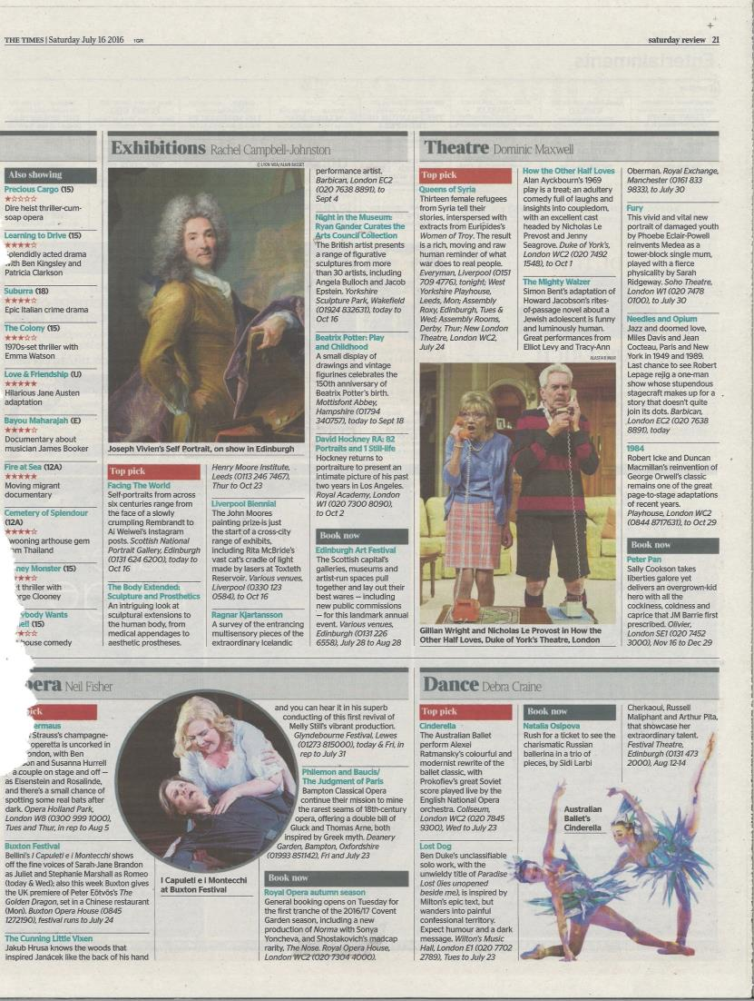
Queens of Syria – PR Report

THE TELEGRAPH 16.07.16
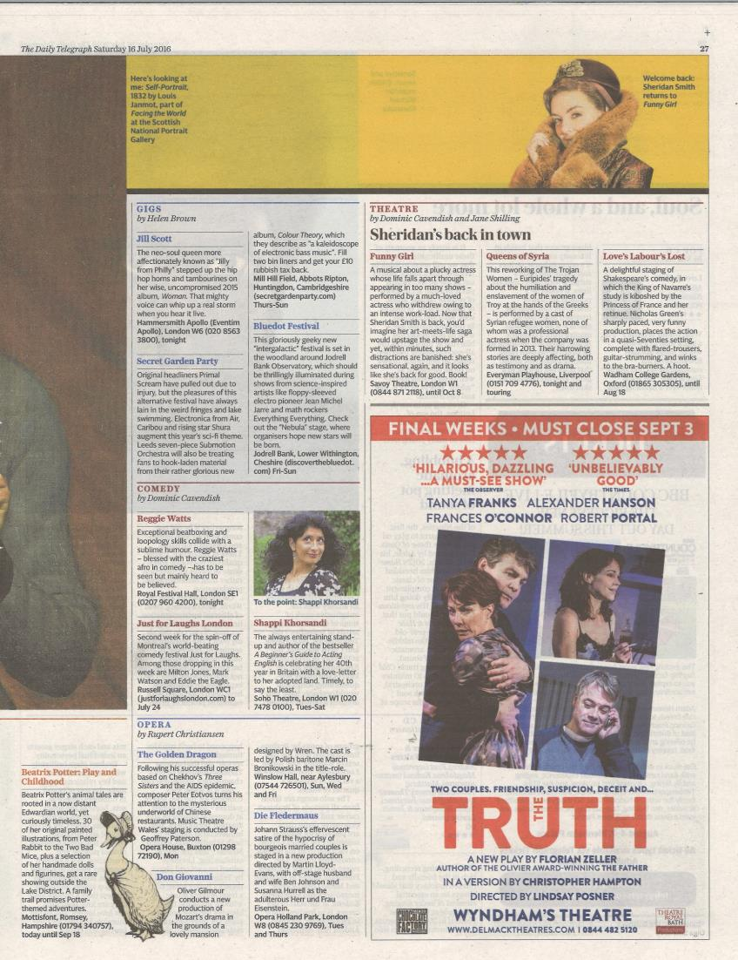
Queens of Syria – PR Report

THE I 16.07.16
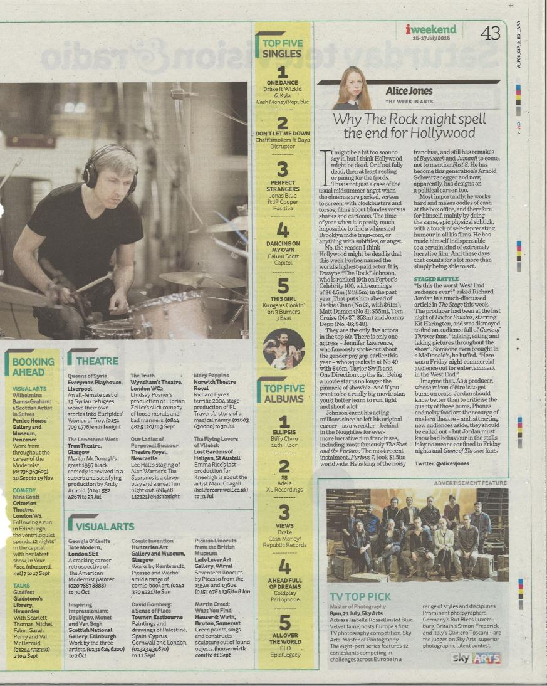
Queens of Syria – PR Report

FINANCIAL TIMES 16.07.16
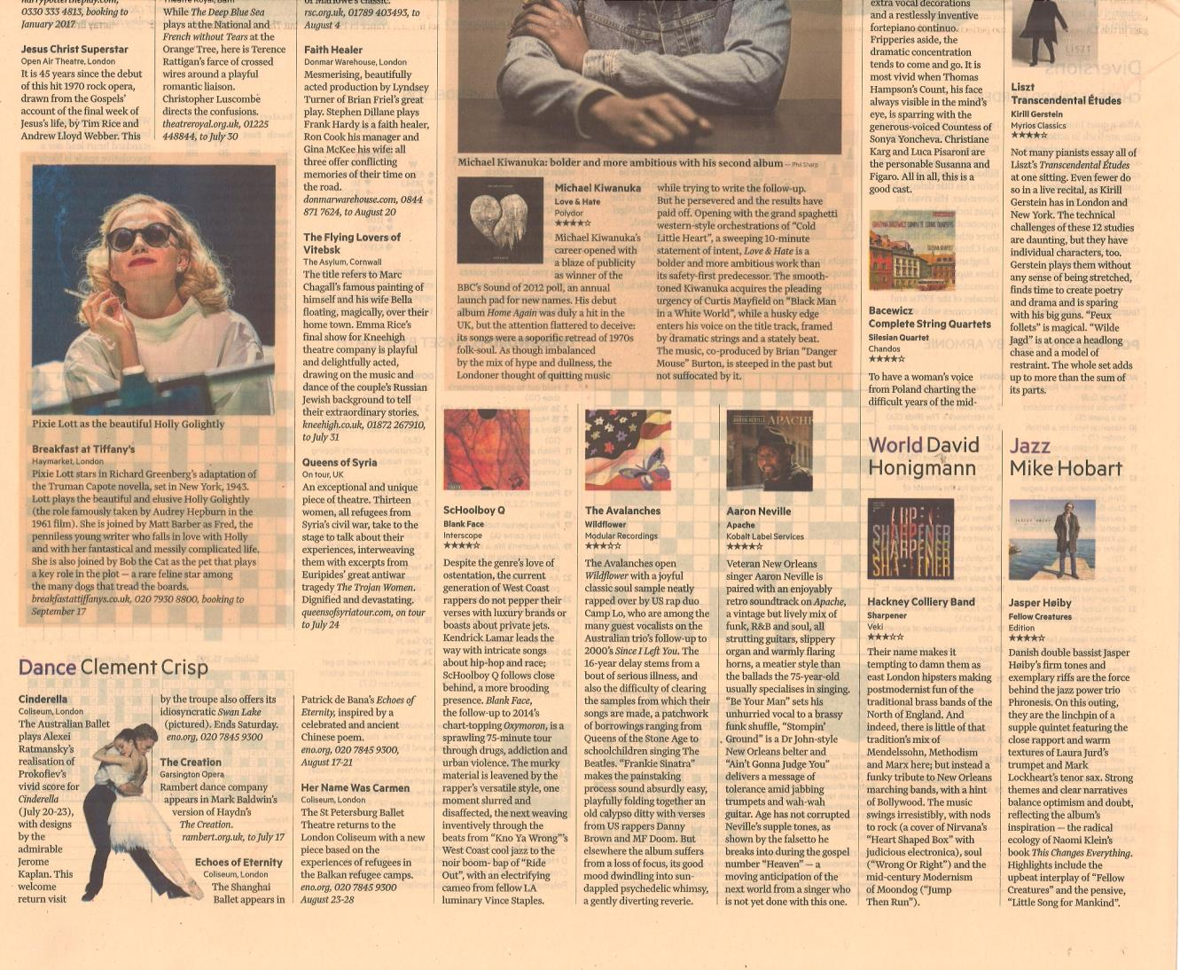
Queens of Syria – PR Report
FINANCIAL TIMES MAGAZINE 16.07.16

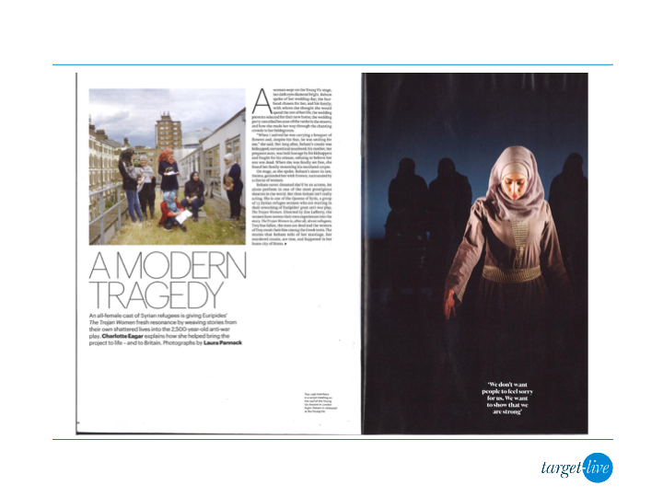
Queens of Syria – PR Report
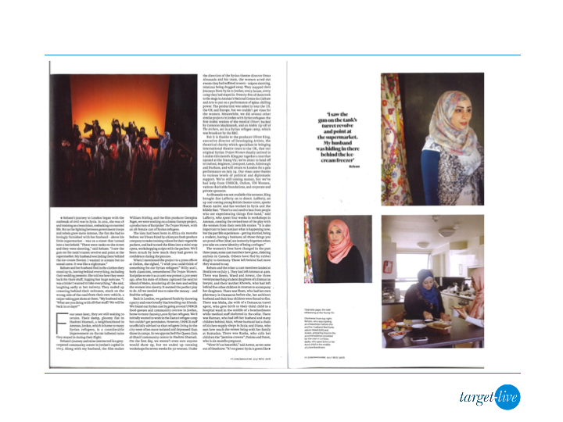
FINANCIAL TIMES MAGAZINE 16.07.16 (CONT’D)
Queens of Syria – PR Report
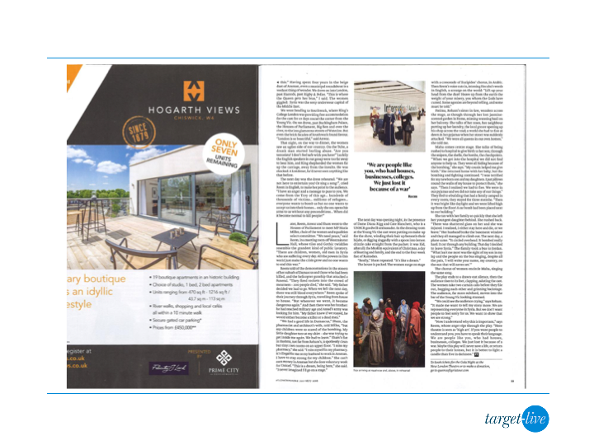
FINANCIAL TIMES 16.07.16 (CONT’D)
Queens of Syria – PR Report

SCOTLAND ON SUNDAY 17.07.16
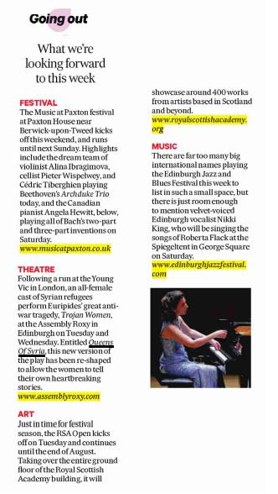
Queens of Syria – PR Report

SUNDAY HERALD 17.07.16
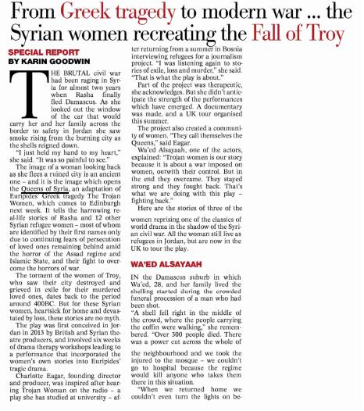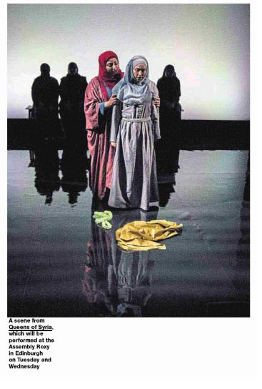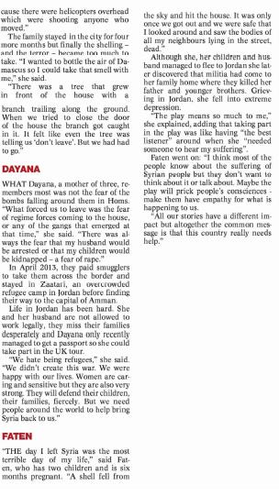

THE SUNDAY TELEGRAPH 17.07.16
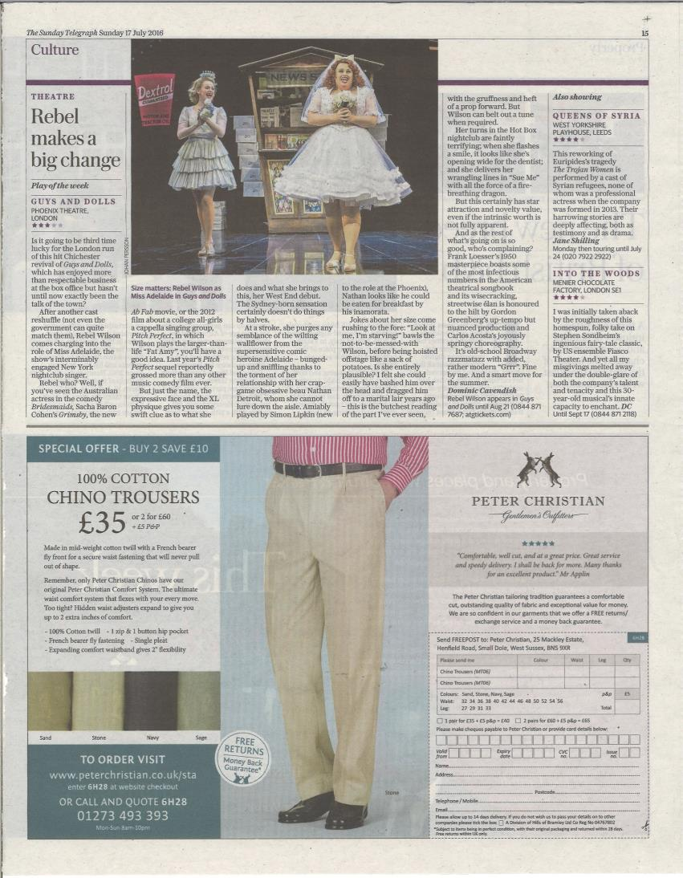
Queens of Syria – PR Report

SUNDAY TIMES CULTURE 17.07.16
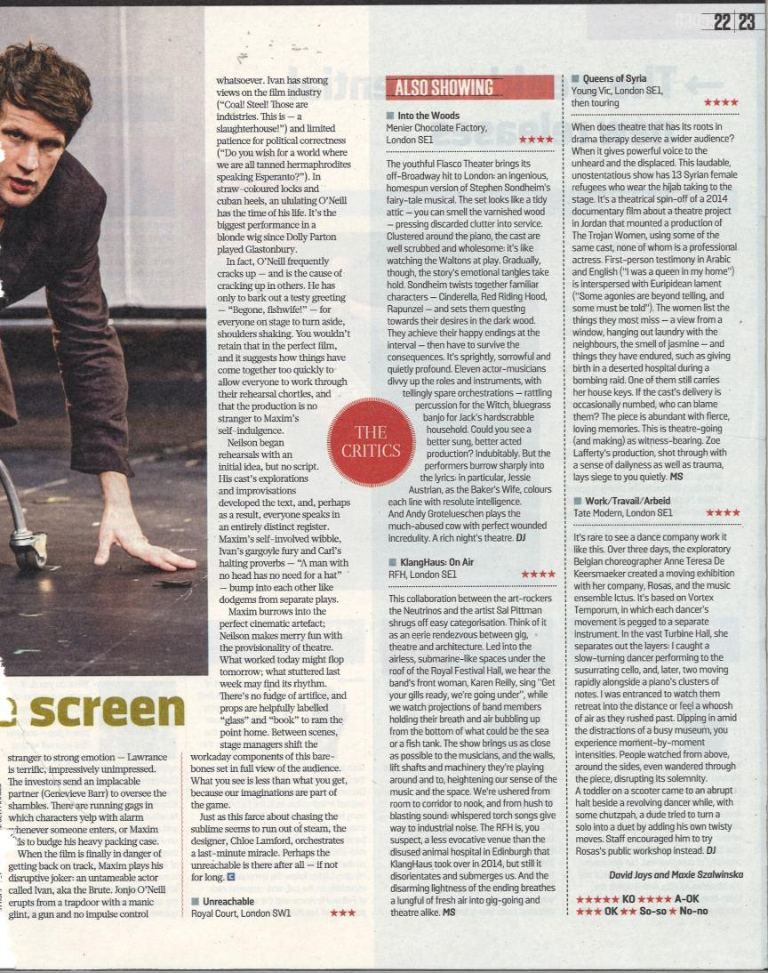
Queens of Syria – PR Report

SUNDAY TIMES CULTURE 17.07.16
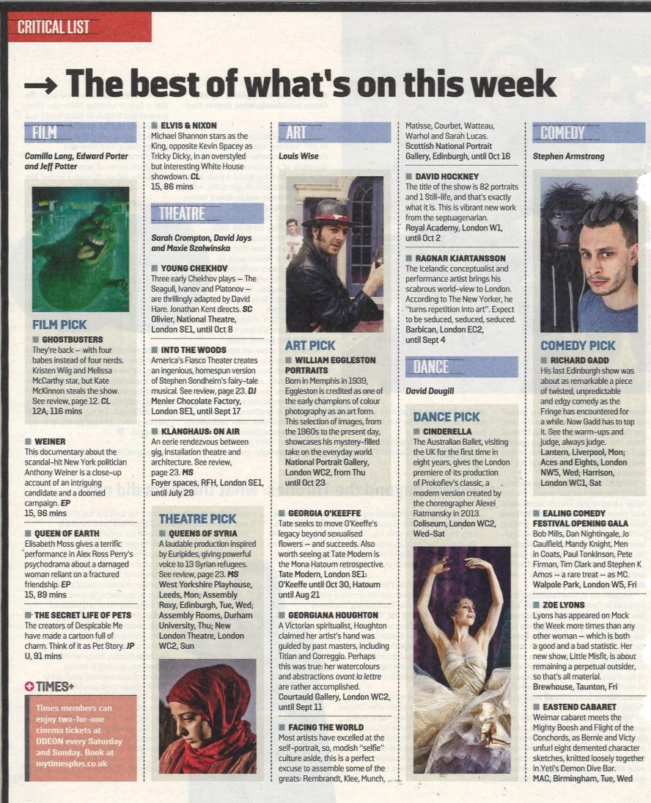
Queens of Syria – PR Report

LIVERPOOL ECHO 18.07.16
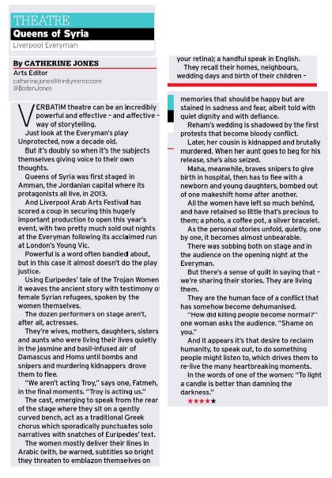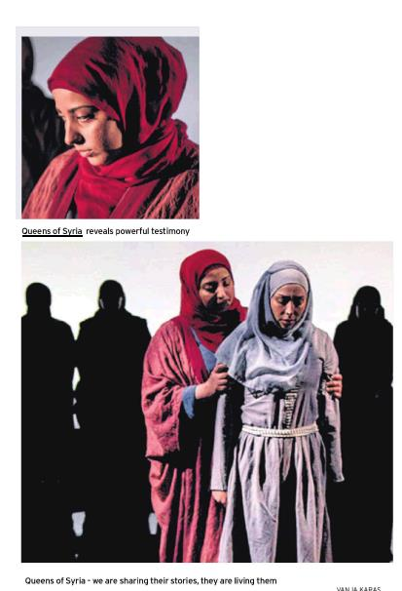
Queens of Syria – PR Report

YORKSHIRE EVENING POST 18.07.16
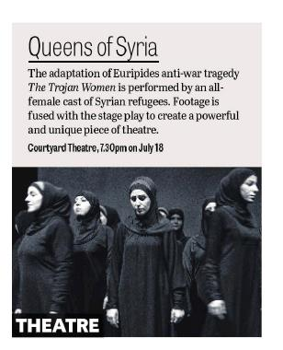
Queens of Syria – PR Report

THE I 18.07.16
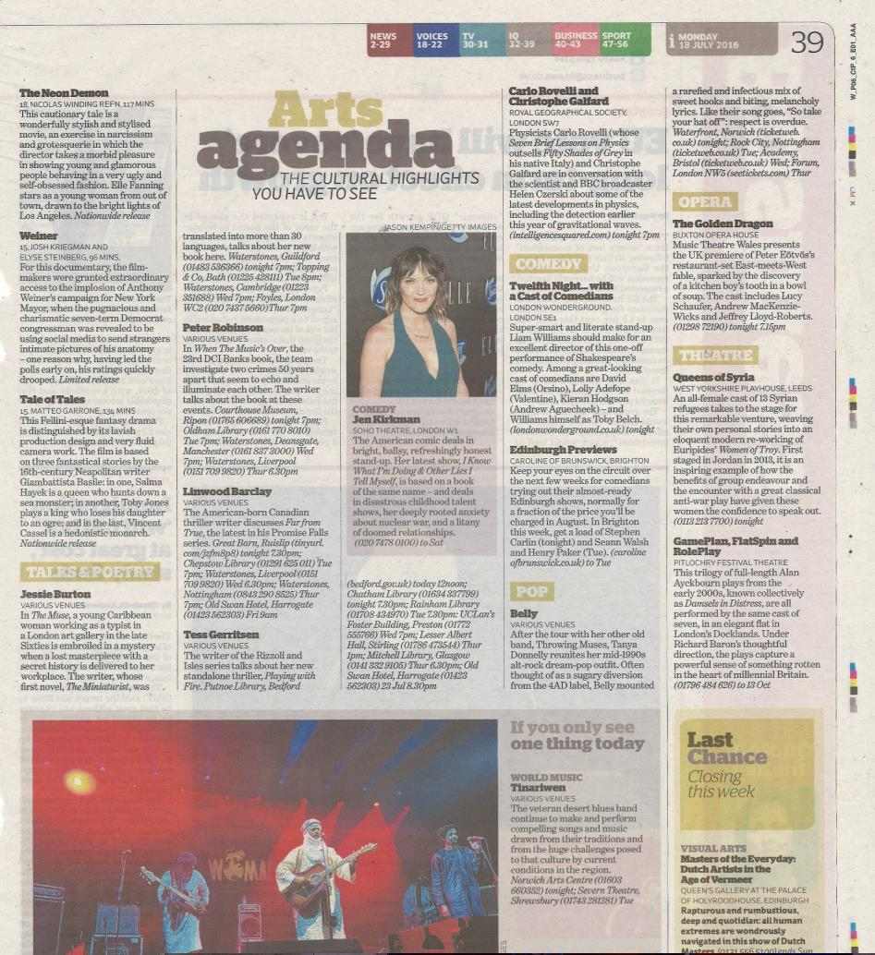
Queens of Syria – PR Report

THE I 20.07.16
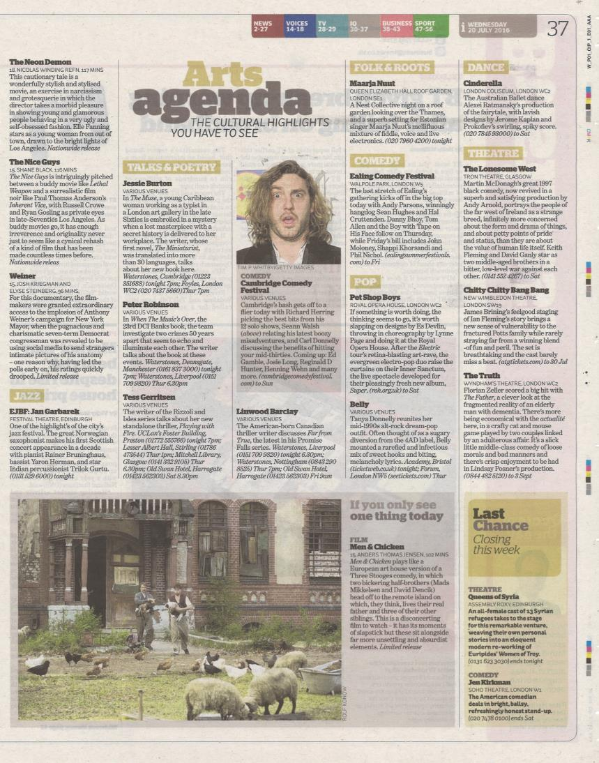

THE I 21.07.16
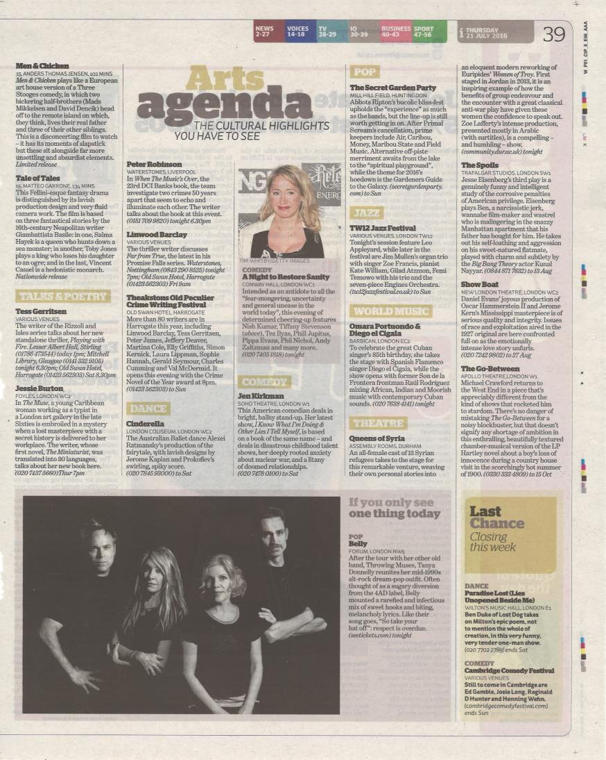

THE HERALD 22.07.16
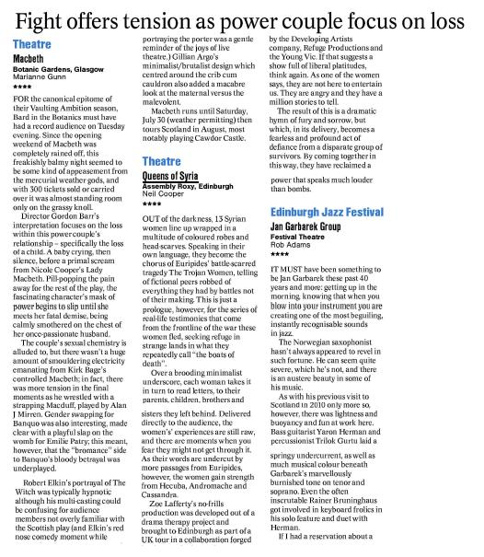

YORKSHIRE POST 22.07.16

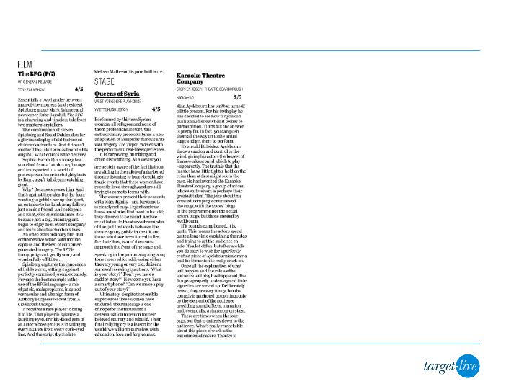
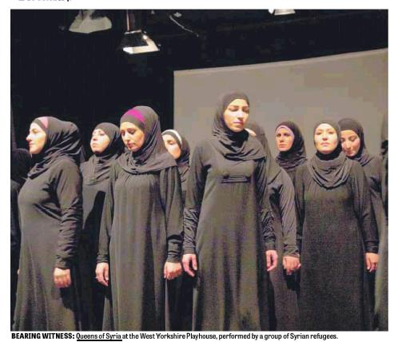

THE TIMES 23.07.16
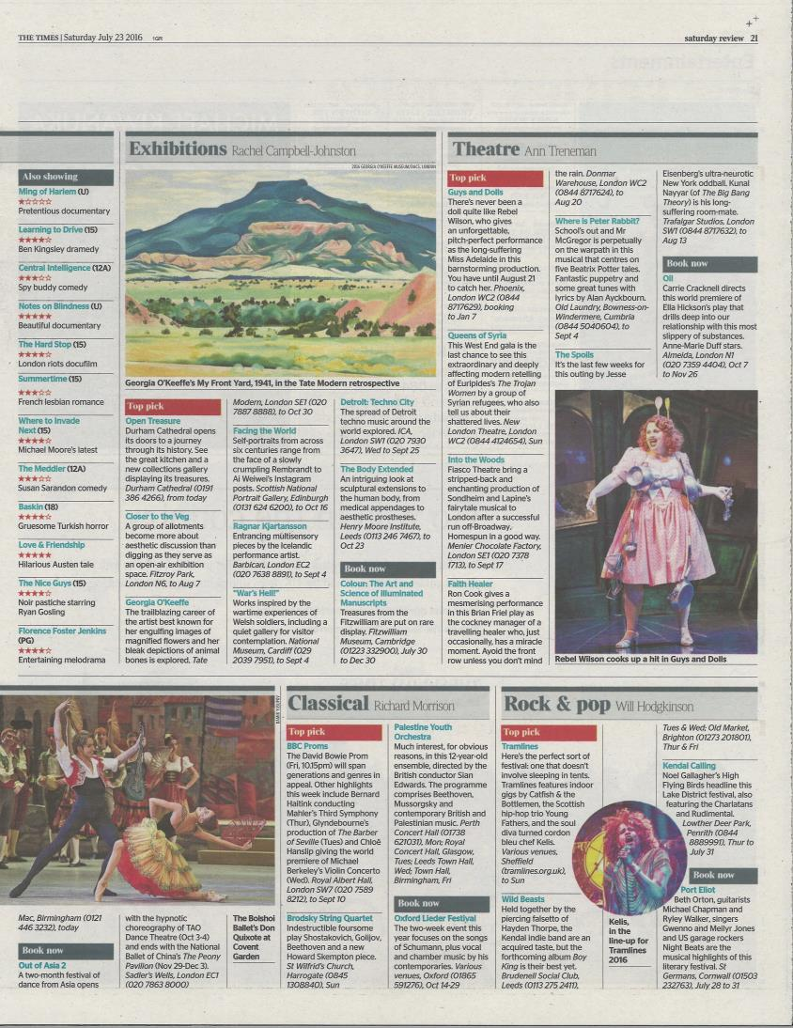
Queens of Syria – PR Report

